**Competitive Analysis**

For competitive analysis I am using Parse as my main comparison. I am using them because they have a great system that allows for creating of classes that resembles an excel or csv file.

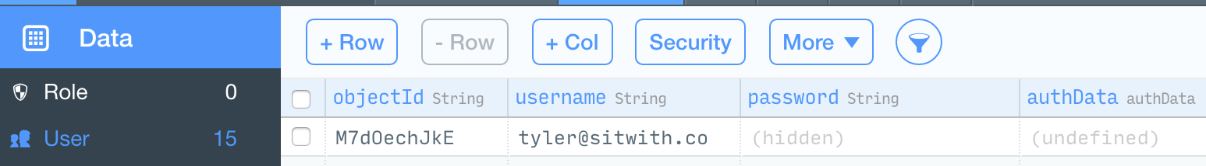

This is what the interface looks like, and it is something that I want to resemble. For every new peace of data I want it to be displayed on the side how many applications you have. Also it is important to cerate new data along with the creation of new buttons and rows. Also, I want to add the feature of being to live update your information that changes everything across.

**Features I want that Parse has:**

* Interface to change data
* Buttons to add columns and rows
* Easy to use modules
* Able to see multiple datasheets and create new ones

It is these features that I want to replicate in my application.

**Anti-features:**

* Running jobs are functions that keep running on a specific time. This is a feature that I would like to add.

**Extra Features:**

* I want to add a feature that includes saving of data does not include csv type data but just anything random to save.